Name: Weekly Language Review – Q4:3 Week of:
Monday | Tuesday
  Write the missing letters. Write the word  own  mmm.. | Draw a picture to show the opposite of BEHIND.  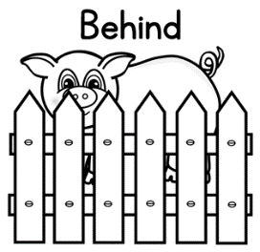
Spell the word.    Mm | Circle the missing word.  Where Why How  ___ much money do you have?
Circle the NOUN. Underline the VERB.  The fire burned. | Add detail to the sentence.  The fire burned.  The ////// fire burned.
Act it out.  - look  - stare  - watch | Draw a picture of something rough.
Which picture matches the underlined word?  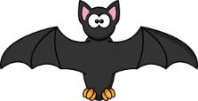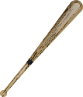  The bat lives in a cave. | Which picture matches the underlined word?  I hit the ball with the bat.

Wednesday | Thursday
Circle the missing word.  for of by  The present is ____ my brother. | How many syllables in computer?   //
Spell the word.  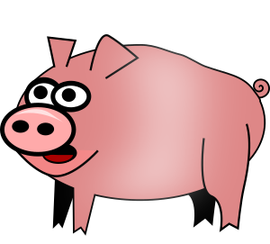  /m | Write the sentence correctly.  i can’t wait for the party  mmm..
Circle the NOUN. Underline the VERB.  The boy painted. | Add detail to the sentence.  The boy painted.  The boy painted //////.
Act it out.  - skip  - walk  - gallop | Draw a picture of something smelly.
Which picture matches the underlined word?  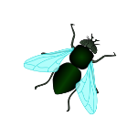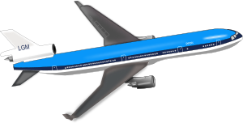  The fly landed on my apple. | Which picture matches the underlined word?  We will fly to Mexico this summer.

Answer Key - Weekly Language Review – Q4:3
Monday | Tuesday
Write the missing letters. Write the word  crown  mmm.. | Draw a picture to show the opposite of BEHIND. In Front
Spell the word.  box | Circle the missing word.  Where Why How  ___ much money do you have?
Circle the NOUN. Underline the VERB.  The fire burned. | Add detail to the sentence.  The fire burned.  Answers will vary.  The ////// fire burned.
Act it out.  - look  - stare  - watch | Draw a picture of something rough.
Which picture matches the underlined word?  The bat lives in a cave. | Which picture matches the underlined word?  I hit the ball with the bat.

Wednesday | Thursday
Circle the missing word.  for of by  The present is ____ my brother. | How many syllables in computer?  3
Spell the word.  pig | Write the sentence correctly.  i can’t wait for the party  I can’t wait for the party!
Circle the NOUN. Underline the VERB.  The boy painted. | Add detail to the sentence.  The boy painted.  Answers will vary.  The boy painted //////.
Act it out.  - skip  - walk  - gallop | Draw a picture of something smelly.
Which picture matches the underlined word?  The fly landed on my apple. | Which picture matches the underlined word?  We will fly to Mexico this summer.

